Chapter 3: Examining Relationships

Objectives: Students will:
Construct and interpret a scatterplot for a set of bivariate data.
Compute and interpret the correlation, r, between two variables.
Demonstrate an understanding of the basic properties of the correlation r.
Explain the meaning of a least squares regression line.
Given a bivariate data set, construct and interpret a regression line.
Demonstrate an understanding of how one measures the quality of a regression line as a model for bivariate data.

AP Outline Fit:
I. Exploring Data: Describing patterns and departures from patterns (20%–30%)
D. Exploring bivariate data
1. Analyzing patterns in scatterplots
2. Correlation and linearity
3. Least-squares regression line
4. Residual plots, outliers, and influential points

What you will learn:

- Data
  - Recognize whether each variable is quantitative or categorical
  - Indentify the explanatory and response variables in situations where one variable explains or influences another
- Scatterplots
  - Make a scatterplot to display the relationship between two quantitative variables. Place the explanatory variable (if any) on the horizontal scale of the plot
  - Add a categorical variable to a scatterplot by using a different plotting symbol or color
  - Describe the direction, form and strength of the overall pattern of a scatterplot. In particular, recognize positive or negative association and linear (straight-line) patterns. Recognize outliers in a scatterplot
- Correlation
  - Using a calculator, find the correlation r between two quantitative variables
  - Know the basic properties of correlation:
    - r measures the strength and direction of linear relationships only
    - -1 ≤ r ≤ 1 always
    - r = ± 1 only for perfect straight line relations
    - r moves away from 0 toward ±1 as the linear relationship gets stronger
- Regression Lines
  - Explain what the slope, b, and the y-intercept, a, mean in the regression line equation
  - Using a calculator, find the least-squares regression line for predicting values of a response variable, y, from an explanatory variable, x, from the data
  - Find the slope and intercept of the least-squares regression line for the means and standard deviations of x and y and their correlation
  - Use the regression line to predict y for a given x. Recognize extrapolation and be aware of its dangers
- Assessing Model Quality
  - Calculate the residuals and plot them against the explanatory variable x or against other variables. Recognize unusual patterns
  - Use r² to describe how much of the variation in one variable can be accounted for by a straight-line relationship with another variable
  - Recognize outliers and potentially influential observations from a scatterplot with the regression line drawn on it
- Interpreting Correlation and Regression
  - Understand that both r and the least-squares regression line can be strongly influenced by a few extreme observations
  - Recognize possible lurking variables that may explain the correlation between two variables x and y
Section 3.I: Introduction to Two Variable Relationships

Knowledge Objectives: Students will:
Identify one of the major influences on the relationship between two variables.
Demonstrate that you remember what W⁵HW means (from Preliminary Chapter).
Explain the difference between an explanatory variable and a response variable.

Vocabulary:
Explanatory variable – helps explain or influences changes in a response variable
Lurking variable – a variable that could influence the relation between two variables, but is not yet identified
Response variable – measures an outcome of a study
W⁵HW – Who, what, why, when, where, how and by whom

Key Concepts:

Homework: none

Example 5 drawing from Section 3.1:

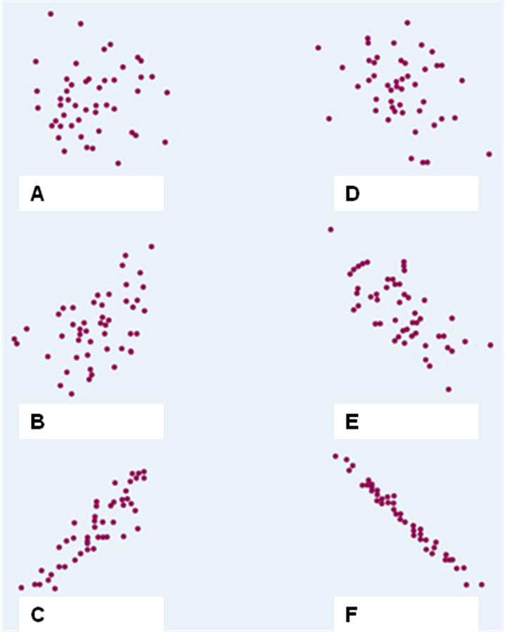
Section 3.1: Scatterplots and Correlation

Knowledge Objectives: Students will:
Explain the difference between an explanatory variable and a response variable.
Explain what it means for two variables to be positively or negatively associated.
Define the correlation r and describe what it measures.
List the four basic properties of the correlation r that you need to know in order to interpret any correlation.
List four other facts about correlation that must be kept in mind when using r.

Construction Objectives: Students will be able to:
Given a set of bivariate data, construct a scatterplot.
Explain what is meant by the direction, form, and strength of the overall pattern of a scatterplot.
Explain how to recognize an outlier in a scatterplot.
Explain how to add categorical variables to a scatterplot.
Use a TI-83/84/89 to construct a scatterplot.
Given a set of bivariate data, use technology to compute the correlation r.

Vocabulary:
Bivariate data – data that has two variables involved with each point
Categorical Variables – variables to which arithmetic operations make no sense
Correlation (r) – the amount of linear association between two variables
Cluster – a group of points distinct from other points in the scatterplot
Negatively Associated – decreasing left to right
Outlier – an individual value that falls outside the overall pattern of the relationship
Positively Associated – increasing left to right
Scatterplot – shows the relationship between two quantitative variables measured on the same individuals
Scatterplot Direction – positive (increasing left to right) or negative (decreasing left to right) association
Scatterplot Form – drawing a single line to represent the data (linear, curved, exponential, etc)
Scatterplot Strength – how closely the points follow a clear form (weak, moderately weak, moderately strong, strong)

Key Concepts:

- Scatter plots should be described by
  - Direction
positive association (positive slope left to right)
negative association (negative slope left to right)
  - Form
linear – straight line, curved – quadratic, cubic, etc, exponential, etc
  - Strength of the form
weak moderate (either weak or strong) strong
  - Outliers (any points not conforming to the form)
  - Clusters (any sub-groups not conforming to the form)

Example 1: Describe the following scatterplots:

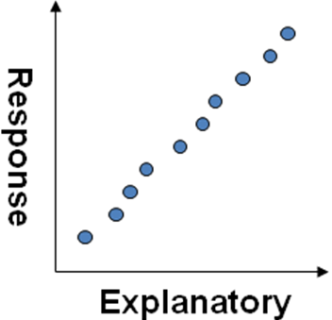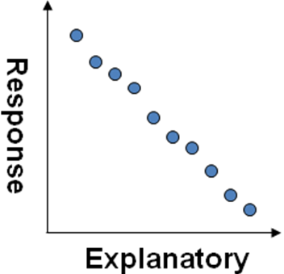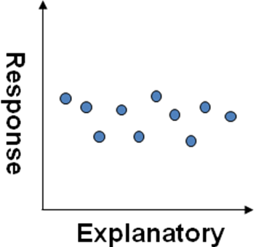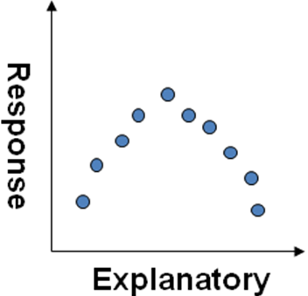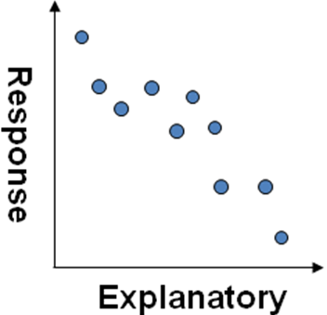

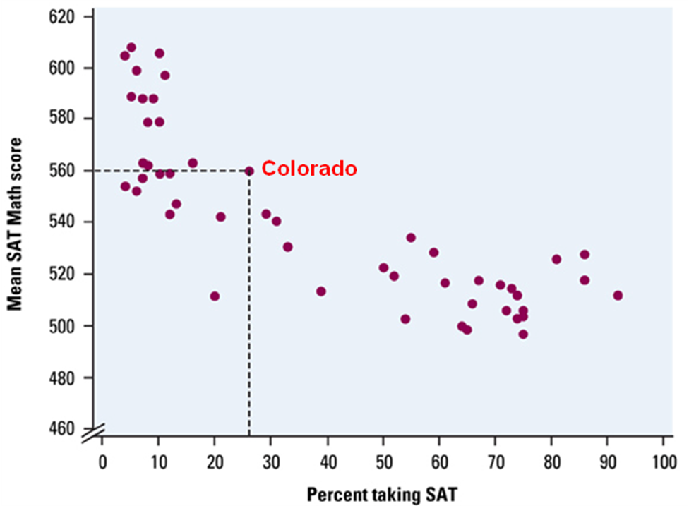
Example 2: Describe the scatterplot to the right:

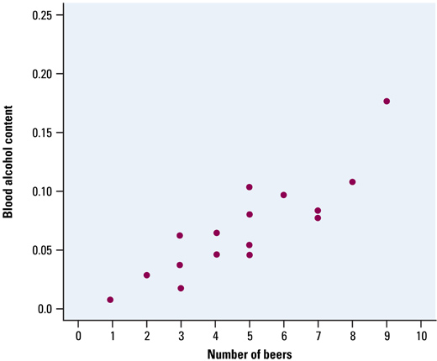

Example 3: Describe the scatterplot to the left:

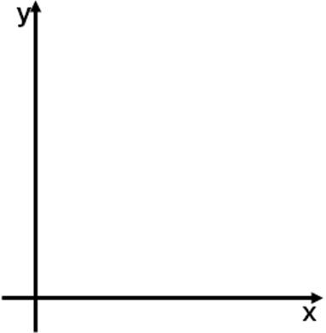
Example 4: Draw a scatterplot and find r for the following data:
 | 1 | 2 | 3 | 4 | 5 | 6 | 7 | 8 | 9 | 10 | 11 | 12
x | 3 | 2 | 2 | 4 | 5 | 15 | 22 | 13 | 6 | 5 | 4 | 1
y | 0 | 1 | 2 | 1 | 2 | 9 | 16 | 5 | 3 | 3 | 1 | 0

Example 5: Match the r values to the Scatterplots on page 2 of the notes
- r = -0.99
- r = -0.7
- r = -0.3
- r = 0
- r = 0.5
- r = 0.9

Homework: 3.7, 3.8, 3.13 – 3.16, 3.21
Section 3.2: Least-Squares Regression

Knowledge Objectives: Students will:
Explain what is meant by a regression line.
Explain what is meant by extrapolation.
Explain why the regression line is called “the least-squares regression line” (LSRL).
Define a residual.
List two things to consider about a residual plot when checking to see if a straight line is a good model for a bivariate data set.
Define the coefficient of determination, r², and explain how it is used in determining how well a linear model fits a bivariate set of data.
List and explain four important facts about least-squares regression.

Construction Objectives: Students will be able to:
Given a regression equation, interpret the slope and y-intercept in context.
Explain how the coefficients of the regression equation, ŷ = a + bx, can be found given r, s_{x}, s_{y}, and (,).
Given a bivariate data set, use technology to construct a least-squares regression line.
Given a bivariate data set, use technology to construct a residual plot for a linear regression.
Explain what is meant by the standard deviation of the residuals.

Vocabulary:
Coefficient of Determination (r²) – measures the percentage of total variation in the response variable that is explained by the least-squares regression line.
Extrapolation – using a regression line to predict beyond its outer most values
Regression Line – a line used to model linear behavior
Residual – difference between the predicted value and the observed value
Least-squares regression line – line that minimizes the sum of the squared errors

Key Concepts:

Least Squares Regression Line
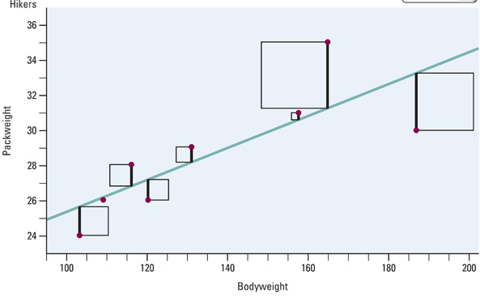

LSR line minimizes the square of the residuals (difference between predicted and observed).
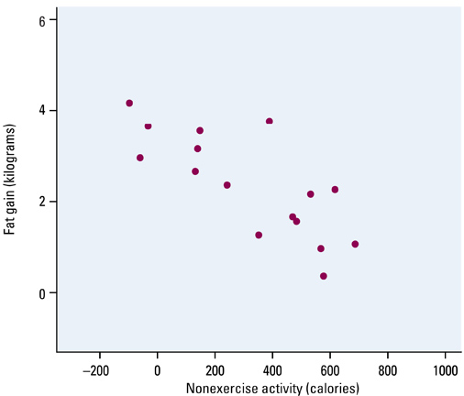
Example 1:
- Describe the scatterplot

- Guess at the line of best fit

- c) Using your calculator do the scatterplot for this data, checking it against the plot in your notes

- d) Again using your calculator (1-VarStats) calculate the LS regression line using the formula (r = -0.7786)

- Now use you calculator to calculate the LS regression line, r and r²

- Calculate r² using the formulas

Residuals Part Two:
Describe the residuals in the following scatterplots and state whether they represent good linear fits
A) 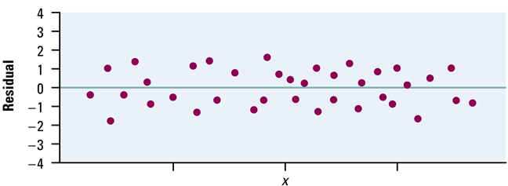

B) 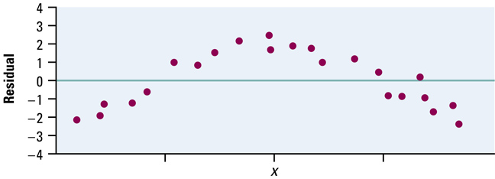

C) 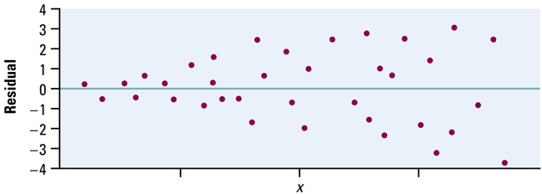
Homework:
Day 1: pg 204 3.30, pg 211-2 3.33 – 3.35
Day 2: pg 220 3.39 – 40, pg 230 3.3.49 - 52
Section 3.3: Correlation and Regression Wisdom

Knowledge Objectives: Students will:
Recall the three limitations on the use of correlation and regression.
Explain what is meant by an outlier in bivariate data.
Explain what is meant by an influential observation and how it relates to regression.
Define a lurking variable.
Give an example of what it means to say “association does not imply causation.”

Construction Objectives: Students will be able to:
Given a scatterplot in a regression setting, identify outliers and influential observations.
Explain how correlations based on averages differ from correlations based on individuals.

Vocabulary:
Influential Observation – observation that significantly affects the value of the slope
Lurking Variable – a variable that may affect the response variable, but is excluded from the analysis

Key Concepts:

Least Squares Regression Facts:
- The distinction between explanatory and response variable is essential in regression
- There is a close connection between correlation and the slope of the LS line
- The LS line always passes through the point (x-bar, y-bar)
- The square of the correlation, r², is the fraction of variation in the values of y that is explained by the LS regression of y on x

Outliers vs. Influential Observations:
- Outlier is an observation that lies outside the overall pattern of the other observations
  - Outliers in the Y direction will have large residuals. but may not influence the slope of the regression line
  - Outliers in the X direction are often influential observations
- Influential observation is one that if by removing it, it would markedly change the result of the regression calculation

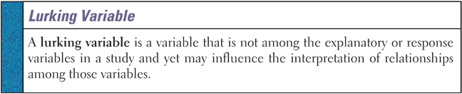

Since lurking variables are often misused by AP Stats students, using the words extraneous variables is a better bet. It does not carry the specific meanings that lurking does to the AP Stat test readers.

Other Items
- Remember association does not mean causation! Instances of Rocky Mt spotted fever and drownings reported per month are highly correlated, but completely without causation

Individual versus Summarized Data:
- When we looked at individual values, they had much broader spreads (variances) than when we looked at the distributions of x-bar
- Same is true with correlations based on averaged data – strong correlations may exist between averages, but individuals will have much greater variances
- Correlations based on averages are usually too high when applied to individuals.

Example 1: Does the age at which a child begins to talk predict later score on a test of metal ability? A study of the development of 21 children recorded the age in months at which they spoke their first word and their later Gesell Adaptive Score (GAS).

Child | Age | GAS | Child | Age | GAS | Child | Age | GAS
1 | 15 | 95 | 8 | 11 | 100 | 15 | 11 | 102
2 | 26 | 71 | 9 | 8 | 104 | 16 | 10 | 100
3 | 10 | 83 | 10 | 20 | 94 | 17 | 12 | 105
4 | 9 | 91 | 11 | 7 | 113 | 18 | 42 | 57
5 | 15 | 102 | 12 | 9 | 96 | 19 | 17 | 121
6 | 20 | 87 | 13 | 10 | 83 | 20 | 11 | 86
7 | 18 | 93 | 14 | 11 | 84 | 21 | 10 | 100

- What is the equation of the LS regression line used to model this data?

- What is the interpretation of this data?

- Are there any outliers?

- Are there any influential observations?

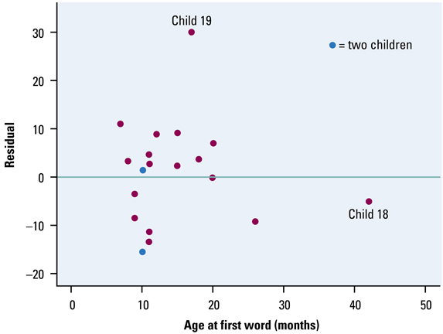
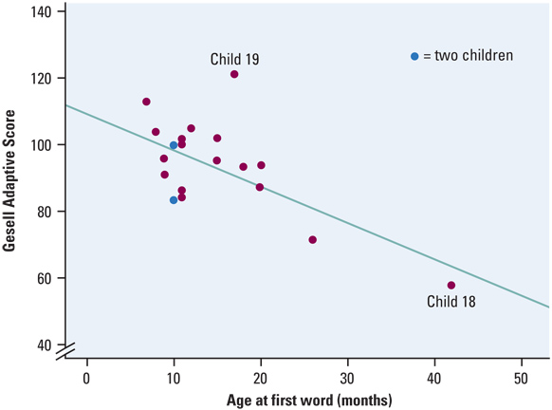

Homework: pg 242-3 3.63-67
Chapter 3: Review

Objectives: Students will be able to:
Summarize the chapter
Define the vocabulary used
Know and be able to discuss all sectional knowledge objectives
Complete all sectional construction objectives
Successfully answer any of the review exercises

Construct and interpret a scatterplot for a set of bivariate data.
Compute and interpret the correlation, r, between two variables.
Demonstrate an understanding of the basic properties of the correlation r.
Explain the meaning of a least squares regression line.
Given a bivariate data set, construct and interpret a regression line.
Demonstrate an understanding of how one measures the quality of a regression line as a model for bivariate data.

Vocabulary: None new

TI-83 Instructions for Scatter Plots
- Enter explanatory variable in L1
- Enter response variable in L2
- Press 2nd y= for StatPlot, select 1: Plot1
- Turn plot1 on by highlighting ON and enter
- Highlight the scatter plot icon and enter
- Press ZOOM and select 9: ZoomStat

TI-83 Instructions for Linear Correlation, r
- With explanatory variable in L1 and response variable in L2
- Turn diagnostics on by
  - Go to catalog (2nd 0)
  - Scroll down and when diagnosticOn is highlighted, hit enter twice
- Press STAT, highlight CALC and select
4: LinReg (ax + b) and hit enter twice
- Read r value (last line)

TI-83 Instructions for Linear Regression and Plotting the Regression Line

- 2nd 0 (Catalog); scroll down to DiagnosticON and press Enter twice (like Catalog help à do once)
- Enter “X” data into L1 and “Y” data into L2
- Define a scatterplot using L1 and L2
- Use ZoomStat to see the data properly
- Press STAT, choose CALC, scroll to LinReg(a+bx)
- Enter LinReg(a+bx)L1,L2,Y1
Y1 is found under VARS / Y-VARS / 1: function

TI-83 Instructions for Residuals and SSE

- After getting the scatterplot (plot1) and the LS regression line as before
- Define L3 = Y1(L1) [remember how we got Y1!!]
- Define L4 = L2 – L3 [actual – predicted]
- Turn off Plot1 and deselect the regression eqn (Y=)
- With Plot2, plot L1 as x and L4 as y
- Use 1-VarStat L4 to find sum of residuals squared

Homework: pg 251 – 255; 3.78-82, 3.84-86

